The Viability of Third Generation Renewable Energy Technologies:
An Examination of Potential Replacements for Fossil Fuel Energy Sources

Hilary Hershner
Kevan Hudson
Mitch Ingstad

Environment, Technology And Society

Section 05, Group 3

Abstract

We are a society heavily dependent on fossil fuels. These fuels, which facilitate our advancement and improving lifestyles, are causing irreparable harm to the environment in which we dwell. There are a number of alternative, renewable sources of energy that can replace these fossil fuels, though many of the technologies already being implemented are either prohibitively expensive or incapable of providing adequate energy to serve as a replacement source. Hope may lie in what are known as third generation renewable energy technologies. These technologies are not yet fully developed, though their early incarnations are already being implemented and tested around the world. A question of vital importance to this and coming generations is: are these technologies viable, can they replace dwindling and harmful carbon based energy sources? Sadly, the answer to this question is one that is not determined outright by the potential of these technologies, but rather the systems that dictate our society. The viability of these technologies hinges on the willingness of producers and consumers alike to sacrifice, to give up profit, to forgo cheap, abundant energy, and to embrace new, cleaner, greener, albeit more expensive technologies.

Introduction
We live in a society that is wholly dependent on the availability of energy, be it electricity, or energy to power transportation, industry or agriculture. The vast majority of this energy comes from the combustion of various fossil fuels, a finite, and possibly dwindling resource. Mankind’s utilization of fossil fuels has allowed for the advancements in technology and know-how that make modern day society possible. However, this addiction to fossil fuels has a price, a price that has been largely paid by the surrounding environment, but now threatens to demand payment from the society that has run up the bill. Perhaps the greatest problem facing the world today is the issue of global warming. Global warming creates a threat to both the physical environment and its inhabitants. The threats of global warming range from rising sea levels to drought, increased air pollution and even increased rates of infectious diseases spread by insects (nrdc.org). Global warming is caused directly by the introduction of greenhouse gases into the atmosphere. Of these greenhouse gases, the most prevalent is carbon dioxide (CO2). Energy production constitutes a major source of CO2 emissions. In the interest of curbing these emissions, there has been significant attention paid to the possible role of alternative energy sources in replacing fossil fuels as the primary fuel source in alternative energy. While several alternative energy practices have already been instituted, fossil fuels remain the primary fuel source for energy production around the world (iea.org). The advancement of existing, and development and refinement of new alternative energy technologies is critical to curb the growing rates of carbon emissions worldwide and halt the advance of global warming.
Background
The primary interest in alternative energy sources lies in those that may be termed renewable. These are resources that are replenished or renewed at a rate faster than they are consumed. Fossil fuels fail to fall under this definition due to the fact that the formation of coal, natural gas and petroleum take thousands of years and immense geologic pressures and specific conditions. Renewable energy technologies are generally divided into three sub-categories. These categories are based largely on the resources location in the process of development and implementation. The first two “generations” of renewable technologies are those that have already been implemented in various ways. As Figure 1 illustrates, in 2009 only 16% of total global energy production came from renewable sources, all of which are considered first or second generation technologies. An examination of these existing technologies can help clarify why the only account for such a small proportion of energy production. This clarification leads to the question: What new technologies are available for energy production and can they fare any better than existing technologies?

Figure 1

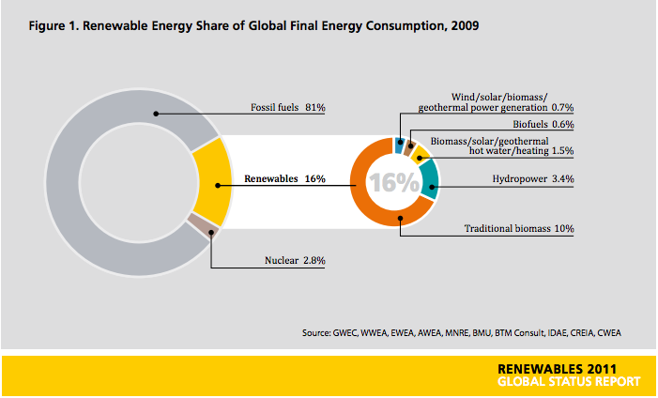
This graphic, taken from the Renewable Energy Policy Network’s 2011 Global Status Report details the distribution of global energy production. It is important to note that of the 16% attributed to renewable sources, 10% is from traditional biomass. This likely includes practices such as the burning of wood for heat and thusly may skew the proportion of energy from “modern” renewables.

First Generation Renewables
The use of renewable energy sources is not a new approach. The first generation of renewable technologies may have been implemented up to 100 years ago. According to the IEA, these technologies, which include hydropower, biomass combustion and geothermal power and heat, emerged from the industrial revolution late in the 19th century.
Hydropower
Hydropower presents a flexible and readily available source of renewable energy. While hydropower is one of the earliest renewable technologies, the IEA estimates that only 5% of the global potential capacity (150 – 200 GW) is being exploited. This fact may be explained by three distinct factors. Hydropower requires a river with a significant enough head drop and fast enough flow rate, limiting potential build sites to major rivers. The areas surrounding these major rivers are often home to large human populations, populations that would likely be displaced by the subsequent flooding following a hydro facility installation. Lastly, hydropower involves high and potentially restrictive initial construction and operation costs, but incurs little generation costs, ranging from $0.03/kWh to $0.04/kWh.

Biomass Combustion
The burning of biomass (organic plant material) to produce energy is a well-developed technology. While the burning of biomass does produce CO2, it is generally regarded to be a “carbon-neutral” technology in that the plants absorb carbon during the growing process. Any number of materials may be used to constitute biomass fuel, however, wood contains the highest energy potential. Wood, when thoroughly dried, can produce approximately 7,000 BTU/lb. This is approximately half of the potential BTU produced from coal. In addition to limited energy output, biomass requires significant land areas to grow sufficient amounts of fuel.
Geothermal
Geothermal as an energy source was long thought to only be feasible on or near tectonic plate boundaries, though advances have now allowed for its use virtually anywhere in the world. The use of geothermal in the context of first generation technologies is limited largely to heating and cooling. While advanced geothermal techniques such as hot dry rock geothermal are being used to produce electricity, they are classified as third generation and will be discussed under that heading.
Second Generation Renewables
Renewable energy sources gained significant public attention following the oil crisis of the 1970’s and the “discovery” of global warming around the same time. These technologies saw significant investments into their research and development. As a result these technologies are now available in the market and are actively being used to contribute to power generation. These technologies continue to gain support in light of global warming and many are subject to government subsidies encouraging their use. These technologies include solar power/heat and photovoltaic, wind energy, and modern forms of bioenergy.
Solar Power/Photovoltaic
Harnessing the power of the sun provides a virtually infinite power source, a premise that lies at the heart of solar power. Solar power is currently being used, primarily for hot water production, in many countries around the world. In order for this technology to become a cost effective means of power production significant reductions in cost would be necessary. Photovoltaics have enjoyed a significant cost reduction in the last two decades. However, this technology is not widely used, with Japan, Germany and the US accounting for over 85% of the current capacity (NREL). Solar energy as a whole remains only a minor contributor to energy production, accounting for approximately 0.1% of electricity generation in the US in 2011 (EIA).
Wind Energy
Wind energy has become an affordable and reliable source of alternative, renewable energy. Continued research and development has led to consistently larger turbines, though the average size is only 2 MW. Despite the advances in wind energy and turbine technology, wind energy remains a minor contributor to global energy. According to the US EIA, wind energy accounted for less than 3% of US electricity generation in 2011. Ultimately, the high installation and maintenance cost of wind turbines coupled with limited output curtails wind energy’s potential as a major source of renewable energy.

Modern Bioenergy
The scope of modern bioenergy encompasses a number of specific technologies. Included in these technologies are biofuels, such as ethanol, E85, and biodiesel. These fuel alternatives seek to decrease the global consumption of oil. Also included in modern bioenergy is so called “co-firing.” Co-firing involves burning biomass fuel sources along with traditional fuel sources (coal or natural gas) for electricity generation. The IEA states that biomass can account for up to 15% of the energy input in a power plant, and, many coal-fired plants can become co-firing units with little or no modification. As with simple biomass combustion, co-firing and biofuels require the dedication of land and resources to ensure the sustainability of the biomass fuel source. As a result, bioenergy struggle to remain competitively priced in comparison to traditional fossil fuels.

Figure 2

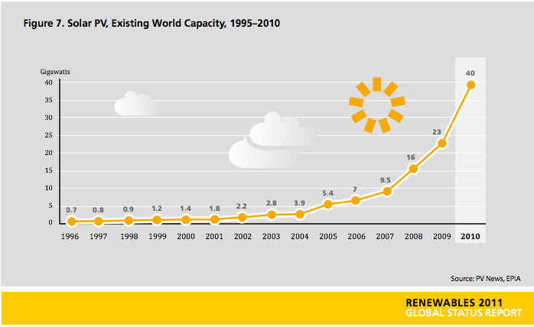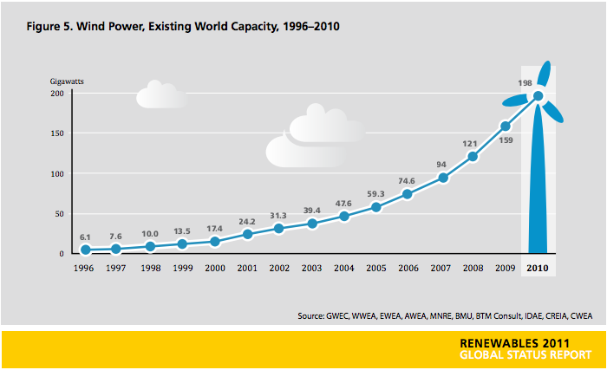
Despite the drastic increases in global use of both photovoltaics (left) and wind power (below) over the last 15 years, both technologies remain only minor contributors to global energy production.
Source: Renewable Energy Policy Network 2011 Global Status Report

Third Generation Renewables
Third generation renewable energy sources are those alternative sources that are still largely in the developmental phase. These technologies hold significant promise, though they are not yet commercially available for market integration. Continued research and development, fueled by continued investment is necessary to introduce these technologies into the global power generation market. The technologies include: biomass gasification, biorefineries, hot dry rock geothermal and tidal or ocean power. It is these technologies that this article seeks to explore in depth. Only through a careful examination of the potential these technologies possess and the likelihood of their successful integration into global energy production can one gain insight into their potential viability as a tool to be utilized to help end dependence on fossil fuels and curb the rising concentrations of greenhouse gases which cause and exacerbate global warming.

Scope of study
While an examination of total global energy production is necessary to gain an in depth understanding of how the use of fuel sources effects both carbon output and in turn global warming, such an examination is beyond the scope of this paper. In order to narrow the field of both conventional and alternative fuel sources to a more manageable size, this paper will focus primarily on electricity generation. An examination of the methods, both current and potential, coupled with the fuel sources used in electricity generation will offer an excellent base of comparison on which to judge the viability of emerging third generation renewable energy sources. In order to establish a baseline to which these alternatives will be compared, one must analyze the current fuel sources utilized. In conducting this examination, the primary focus will fall on coal and natural gas. Other sources are excluded for a number of reasons. Oil accounts for a miniscule percentage of electricity production and is therefore not examined. Nuclear power, which accounts for up to 20% of global electricity generation, brings with it a host of concerns. The potential for disaster, be it from all out failure, to radioactive water or gas leaks, limits the public acceptance of nuclear power as a widespread fuel alternative. Additionally, the issue of waste disposal presents another barrier to more widespread nuclear powered electricity generation. For example, the US, the world’s leader in nuclear electricity generation, lacks a permanent storage unit for the disposal of nuclear waste, a fact that exemplifies the complexities of the issue. For these reasons, nuclear power is also excluded from this examination.
Objectives
The ultimate aim of this article is to address the potential viability of third generation renewable energy sources. Reviewing the processes involved in a number of these technologies and then assessing approximated costs in comparison with existing technologies will determine this viability. Assessing the potential success of these technologies is critical, as the global demand for energy continues to climb. This evaluation will consider current costs of existing technologies, though it is important to acknowledge that the finite nature of fossil fuels will inevitably lead to significant price increases.

Methods
The vast amount of information contained within this article is not original research. The data compiled to draft this article comes from a number of sources, and relies heavily on existing and ongoing research. Fortunately, there is a wealth of information regarding the existing renewable energy technologies, and also, due to significant interest within the scientific community, a vast array of knowledge and ongoing studies regarding fossil fuel use and the accompanying carbon emissions.
The vast majority of information pertaining to first and second generation technologies was collected from energy agencies. In particular, the International Energy Agency, an autonomous energy organization with 28 member countries, and the US Energy Information Administration, a statistical and analytical agency within the Department of Energy, served as sources for a great deal of general and specific information. Through an examination of the publications made public on these organization’s websites much of the data on energy usage, fuel sources, renewable technology growth and limitations, carbon emission levels and potential costs was compiled.
The data discussed in the Biomass gasification section was collected from a selection of scholarly articles as well as from websites that display research on the topic of biomass gasification. The publishers of the websites include companies that practice biomass gasification as an energy generator and government agencies that are responsible for developing renewable energy technologies. Researchers who have done their own experiments and data collection and analysis wrote the scholarly articles. From these sources I gathered my data and applied it to our scope of study.
The method used to obtain information regarding geothermal energy, the three types of geothermal power plants, tidal energy and the two types of tidal power plants was to utilize internet searches using search engines such a Google, as well as using the online database Academic OneFile through the Rod Library’s website at the University of Northern Iowa. The articles used were from non-profit organizations and from other organizations not associated with the government.

Results and Discussion

The dangers of fossil fuels
The continued use of fossil fuels, particularly coal and natural gas, for electricity generation is somewhat inevitable. Coal alone accounts for 40% of global electric generation fuel, with natural gas accounting for another 23% (Figure 1). Nearly two-thirds of the world’s electricity comes from the combustion of carbon rich fossil fuels. While the carbon output of these fuels is not the sole source of CO2, the primary greenhouse gas, it constitutes a major component of the current CO2 emissions. Bituminous coal, the primary fuel source for electricity generation is made up of anywhere between 45% and 85% carbon, possesses a high heat value, and is cheap, as little as $9.15/ton in late May of 2012 according to the EIA. Within the US alone, approximately one million tons of coal was burned in 2011 (EIA). Based on the fact that roughly two million MWh of electricity were generated from this coal, one can calculate that roughly one pound of coal produces one kWh of electricity. Amazingly, each pound of coal combusted produces more than double it’s weight in carbon dioxide. In 2011 more than 30 billion metric tons of carbon dioxide were released into the atmosphere from electricity generation (REN21). Natural gas also plays a role in this astronomical figure. While natural gas does burn cleaner than coal, it also releases carbon dioxide into the environment. Natural gas often has a higher heat value than coal, ranging from 17,500 BTU to 23,500 BTU, and releases approximately half as much CO2 (Natural Gas Air Emission Facts). Figure 3 below highlights the distribution of fuel sources that are used for electricity generation while figure 4 illustrates carbon emissions by fuel type. It is important to note that electricity generation accounts for the largest portion of carbon emissions in the US, surpassing even transportation.

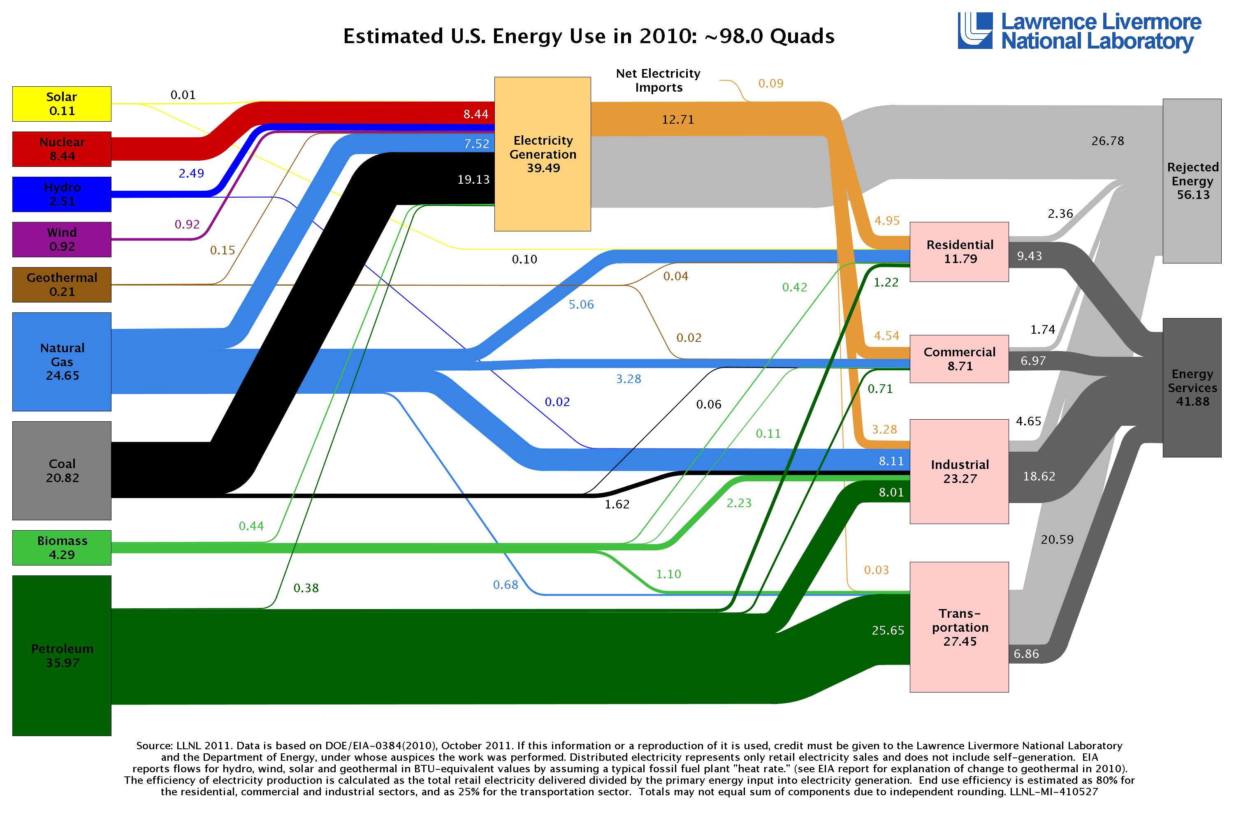
This graphic above (Figure 3) illustrates a breakdown of US energy use, both by fuel source and the sector consuming the energy. Figure 4 (below) illustrates US carbon emissions by fuel source and sector. Source: Laurence Livermore National Laboratory

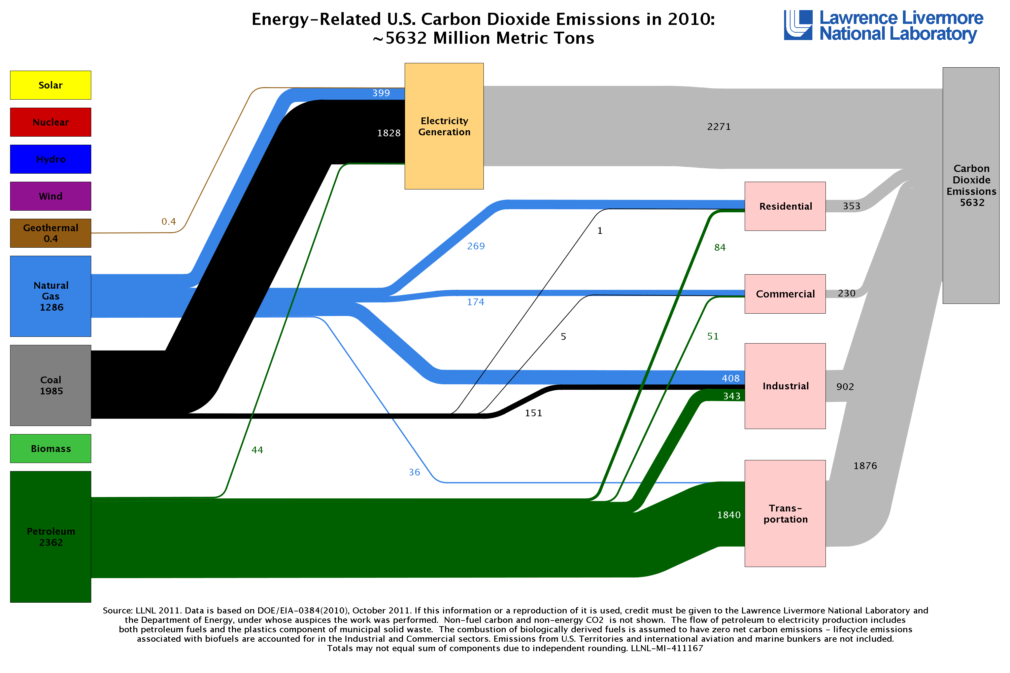

Biomass Gasification
Gasification
The gasification of biomass is a process that takes organic matter, such as plants, grasses, and agricultural crops containing the elements hydrogen, oxygen, and nitrogen and turns them into energy. The organic matter is either incompletely combusted or broken down by enzymes to produce what is known as producer gas. Producer gas often consists of carbon monoxide (CO), hydrogen (H2), and methane (CH4). These gases can be used to produce heat, they can be used to replace furnace oil, and they can be made into methanol which is a chemical heavily desired for its uses as fuel and chemical feedstock (What is Biomass). Biomass is a more ecological energy option because its impact on the environment is significantly less severe than the impact of fossil fuels. The major difference between biomass and fossil fuels is when biomass is broken down the carbon dioxide that is released is not being added to the atmosphere, but rather replacing the carbon dioxide it had broken down (What is Biomass). The biomass materials draw their carbon from the soil and the atmosphere while they are still living. This means that the carbon emissions released from biomass is carbon that already existed in the atmosphere. Carbon from fossil fuels, on the other hand, existed in the atmosphere millions of years ago. Therefore, when fossil fuels are burned carbon dioxide is being added to the atmosphere, as opposed to being replaced (What is Biomass).
Biorefineries
Much like a petroleum refinery, which is a facility that converts large amounts of petroleum into multiple fuels for multiple uses, biomass is converted into multiple uses at a biomass refinery. A biorefinery is a facility that converts biomass into fuel, heat, power, and chemicals (NREL). There are multiple processes to break down biomass into energy but there are two primary processes that have proven to be the most efficient. The first is thermochemical or pyrolysis, which is the process of heating the biomass and letting the materials breakdown to produce gases (Rajvanshi). The biomass is put in a container without oxygen and heat is applied to the matter. The products of this process include water, charcoal, oils or tars, and permanent gases including methane, hydrogen, carbon monoxide, and carbon dioxide. Pyrolysis often leads to gasification, which is when oxygen is added to burn the biomass to provide more heat. Gasification the most efficient process as it produces the highest yields of carbon and energy in the gas phase (Rajvanshi). The second type of process is biochemical, which involves the biomass materials being broken down by enzymes. The biomass is collected and undergoes a thermochemical process in the beginning to break down the biomass into soluble sugars, or cellulose. Enzymes then break down the cellulose into simple sugars and they are transferred to a fermenter. The sugars are fermented into alcohols, usually ethanol, and then used to produce energy (Biomass Program). Lignin is another material produced from the biochemical process and it can be burned to produce heat and power (Biomass Program). It can also be converted to other fuels. Biomass is very attractive as a renewable energy source; however, very little experience has been gained from using biomass. It has great potential to be used in agriculture, as its residues are most appropriate for farming energy systems.
Biomass Results & Discussion
The ideal biomass material is wood as it produces 18 to 24 million BTU per ton, roughly the same amount of energy output as coal, 16.2 to 26 million BTU (Elkhorn Biomass). Of course, coal is significantly cheaper but wood also goes wasted by getting burned in slash piles and not utilized for anything. Woody biomass is the second most efficient renewable energy in BTU production as it produces 2.165 quadrillion BTUs per year. This is second behind hydroelectric energy, a first-generation renewable energy source, which produces 2.463 quadrillion BTUs per year. Unfortunately, because we waste thousands of tons of wood each year, it is difficult to rely on the use of wood in biomass gasification (Elkhorn Biomass). Agriculture is an industry that is very abundant in organic matter that can be used for biomass gasification. Farms often have an abundance of plants, grasses, and weeds that can be converted to energy as well as, if the farmers own livestock, manure. All of these materials prove to be very capable sources and if processed correctly could allow farmers to run semi-self-sustaining farms. Because all these materials are being constantly produced through nature, as long as the farm is running these materials will be available. And though these materials may not be as efficient as coal or even wood, together they can produce a substantial amount of energy. Switch grass, one of the most abundant forms of biomass, can produce 13 million BTUs per ton when processed and dry manure can produce up to 17 million BTUs per ton when processed through biomass gasification ((Elkhorn Biomass).
Biomass is a viable resource if it is used in an agricultural setting. The agricultural industry is best fit for a biomass energy system because it has supply of fuel (Rajvanshi). Applying biomass technology to be a viable source of energy to the nation as a whole is not as likely. The problem lies in the lack of biomass fuel that can produce the amounts of energy at a cost relatively close to the cost of burning fossil fuels. The fact is that coal is just too inexpensive and produces more energy than any renewable energy source. To allow biomass to be a viable energy source on the national level there must be more research done for biorefinery efficiency as well as a national conservation of wood and other biomass material (Rajvanshi). Biomass is one of the few renewable resources that could possibly be a replacement to fossil fuels, but right now we do not have the technological means to do so and it is not economically feasible to use it as a major energy source.

Geothermal Energy
Hot Rock Geothermal Power Plants
Geothermal energy is created through the use of the naturally occurring convection cycle in the Earth’s crust. Temperature goes through a cyclical process where the hot temperatures continually rise and then fall. The way that geothermal energy is produced is when the water rises (the water is naturally heated up by the hot rocks deep within the earth) and is seen on the surface in the form of hot springs and geysers (Geothermal Energy Facts). At times, the hot water cannot reach the surface because it encounters an impermeable layer, which then creates a geothermal reservoir (Geothermal Energy Facts). The water here can rise to 700°F (350°C), which is much hotter than hot springs located on the surface (Geothermal Energy Facts). At the plant, when the water becomes heated, it is then sent through a steam turbine where the heat is converted to electricity using a generator; this process is known as electromagnetic induction (How a Geothermal Power Plant Generates Electricity). The next step in the process is cooling the water or working fluid and sending it back to the heat source (How a Geothermal Power Plant Generates Electricity).
There are also three types of plants to create geothermal energy: dry steam (figure A), flash steam (figure B), and binary cycle (figure C) (How a Geothermal Power Plant Generates Electricity). These three types of plants all use steam to generate electricity, which is like other electric plants, but geothermal plants to not require a heating fuel to create steam (How a Geothermal Power Plant Generates Electricity). The type of geothermal plant used depends on the state of water, whether it is liquid or vapor, and its temperature (How a Geothermal Power Plant Generates Electricity). Geothermal dry steam power plants got its name from the fact that the underground reservoirs contain water in its gaseous form (How a Geothermal Power Plant Generates Electricity). The geothermal steam needs to be at least 300°F (150°C), and the steam is sent straight to the turbines. The dry steam power plants are rare (there are only 22, and they are all located in California), but they are the oldest type of geothermal power plant (How a Geothermal Power Plant Generates Electricity).
The second type of geothermal power plant uses flash steam, which refers to the process of vaporization of high-pressure hot water into steam inside a flash tank by lowering the temperature (How a Geothermal Power Plant Generates Electricity). The steam created in the flash tank is then used to drive the turbines, creating electricity. The use of flash steam was first used at a power plant in New Zealand in 1958 (How a Geothermal Power Plant Generates Electricity). The last type geothermal power plant uses the binary cycle. The geothermal binary cycle power plants use water with a low temperature, which can be as low as 135°F (57°C) (How a Geothermal Power Plant Generates Electricity). When a working fluid has a lower temperature than water, the thermal energy flashes the working fluid into steam, which then runs the turbine (How a Geothermal Power Plant Generates Electricity). The working fluid never comes into direct contact with the water from the geothermal reservoirs, so once the water has transferred its energy to the working fluid through the heat exchanger, the water is sent to the reservoir to regain its thermal energy (How a Geothermal Power Plant Generates Electricity). This type of geothermal power plant is not as efficient, but they allow us to gather energy from reservoirs that we would not be able to gather from a flash- or dry-steam reservoir (How a Geothermal Power Plant Generates Electricity).
Results and Discussion
The feasibility of geothermal energy relies on what advantages and disadvantages you want to look into while planning for a geothermal power plant. Advantages to geothermal energy are that it is environmentally friendly, renewable, and sustainable, there is massive potential for energy creation, and it is stable (Geothermal Energy Pros and Cons). Geothermal energy is considered to be environmentally friendly because the carbon footprint is minimal (Geothermal Energy Pros and Cons). Compared to a coal power plant, geothermal power plants releases one eighth of the amount of carbon dioxide released by a coal burning power plant (Geothermal Energy Pros and Cons). Geothermal energy is also renewable, due to the fact that the heat churning in the Earth’s subsurface warming the water in the geothermal reservoir is naturally replenished (Geothermal Energy Pros and Cons). Sustainability is also associated with geothermal power plants due to the fact that the energy used to generate electricity will be at a manageable consumption rate (Geothermal Energy Pros and Cons). The United States generates about 2700 MW of electricity from geothermal power plants, which is only a small portion of what the natural geothermal resources in our Earth have to offer, thus allowing for a massive potential in the production of electricity generated by geothermal power plants (Geothermal Energy Pros and Cons; Geothermal Energy Facts). Lastly, geothermal power plants have an advantage because of the fact that the energy flow from the earth’s core has little fluctuation, unlike wind and solar which can be unreliable (Geothermal Energy Pros and Cons).
Disadvantages of geothermal energy production include environmental issues, surface instability, and cost. As stated before, geothermal energy is more environmentally friendly than harmful, but there are a few drawbacks related to damaging the environment. Geothermal energy production can leave traces of heavy metals such as mercury, arsenic, and boron (Geothermal Energy Pros and Cons). The energy flowing into the power plant is stable, but the creation of electricity from geothermal reservoirs creates surface instability because of hydraulic fracturing which leads to subsidence (Geothermal Energy Pros and Cons). Lastly, geothermal power plants are often expensive: to construct a 1 MW power plant it takes around $2 million to $7 million dollars (Geothermal Energy Pros and Cons).

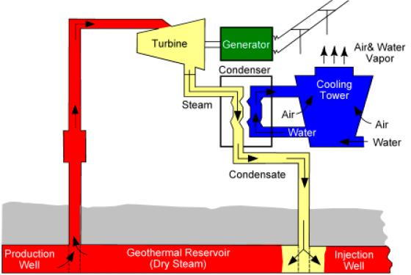 Figure 5: Dry steam geothermal power plant.
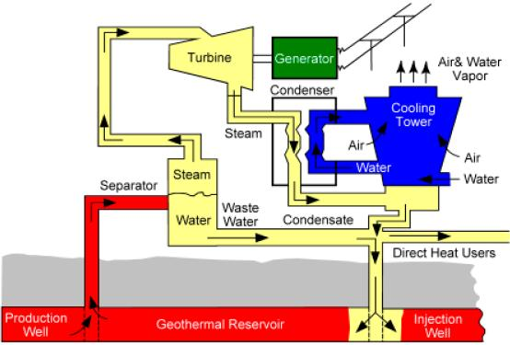
Figure 6: Flash steam geothermal power plant.
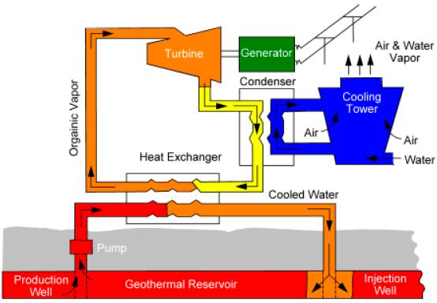
Figure 7: Binary cycle geothermal power plant.

Tidal Energy
Offshore Stream and Barrage Tidal Power Plants
Tidal energy is created using the natural ocean tides due to the pull of the moon’s gravity. The energy created from high tide going to low tide, and vice versa, is captured using undersea turbines. There are two ways in which tidal energy can be exploited, by harnessing offshore tidal streams (figures 8 and 9), and through semi-permeable barrages across estuaries with a high tidal range (figures 10 and 11) (Tidal Energy). Barrages across estuaries allow water to be contained by a floodgate, which then empties through turbines, and tidal streams gather energy using offshore underwater devices similar to a wind turbine (Tidal Energy). Offshore tidal streams use kinetic energy present in tidal currents that can be turned into electricity using modular turbine systems (How Does Tidal Power Work?). These turbine systems are placed in-stream so they can capture the energy from the flow of water, and the turbines can either be horizontal axis, vertical axis, among others (How Does Tidal Power Work?). The systems themselves can be on top of the water, or submerged (How Does Tidal Power Work?).
Barrages can be floating on the water or fixed to the land offshore. When barrages are used, the difference in water level drops on one of the sides, and the water flows through the barrage with the force of gravity, which produces power (How Does Tidal Power Work?). To create the amount of energy needed to operate a barrage, the tidal range must be at least seven meters (Tidal Energy), but can vary between four and a half to 12.4 meters. Barrages across estuaries block the incoming and outgoing tide and have an opening that allows the tide to flow into the basin; the opening is then closed, and when the sea level drops the water in the basin drives turbines to generate electricity (Tidal Energy). Barrages can generate electricity on flood side or on both sides of the barrage (Tidal Energy). The technology required to capture the energy created by tides is well established, but the cost of tidal power is costly which is why there is only one major tidal generating station in the world at the mouth of the La Rance River in France (Tidal Energy).
This barrage station in northern France generates 1 MW of electricity, whereas a goal or nuclear power plant creates 1,000 MW of electricity (Tidal Energy). The total installed capacity of 240 MW is created through the power plant’s 24 turbines (How Does Tidal Power Work). The La Rance tidal power plant generates 240 MW from its 24 turbines (How Does Tidal Power Work), and creates 0.6 TWh annually.
There are other tidal power plants in the world, just none as large and reliable as the one on the La Rance River. Areas of the United States that would be ideal for a tidal power plant would be in the Pacific Northwest, due to the fact that the tides along the coast fluctuate considerably, about 12 feet a day (Tidal Energy). On the Atlantic coast, Maine would be ideal as well, but the machinery there would need to be tough because of the rough undersea environment (Tidal Energy). In countries outside the United States, the Severn River in England has the potential to create 10 percent of the country’s electricity needs if a barrage was created (Tidal Energy). The Bay of Fundy, between the Canadian provinces of Nova Scotia and New Brunswick, has the highest tidal range in the world thus making it a prime location to construct a tidal power plant (Tidal Energy).

Tidal Results and Discussion
To determine the feasibility of tidal power plants, again it is important to determine what trade-offs you are willing to take. Advantages of tidal energy include the fact that it is renewable, green, predictable, effective at low speeds, and that these plants have a long lifespan (Tidal Energy Pros and Cons). Tidal energy is renewable due to the fact that the energy used in generating electricity from these power plants comes from the moon and sun in combination with the earth’s rotation and gravitational axis, which are sources of energy not going anywhere soon (Tidal Energy Pros and Cons). Tidal energy is also environmentally friendly because it does not take up much space, and it does not release any harmful gases into the atmosphere (Tidal Energy Pros and Cons). Tides are also predictable: the high-tide and low-tide cycles are well-known cycles, thus it is easier to construct a barrage or stream generator because engineers know what forces they will be up against (Tidal Energy Pros and Cons). Water is over 748 times denser than air (depending on the elevation), which makes it more effective at generating electricity at lower speeds (Tidal Energy Pros and Cons). Lastly, barrages and stream generators have long life spans, which in turn reduces the cost these power plants can sell their electricity, thus making tides a cost-effective energy source (Tidal Energy Pros and Cons).
Disadvantages of using tides to generate energy include environmental effects, limitations on where these plants can be located, and they are expensive (Tidal Energy Pros and Cons). Due to tidal power plants being a relatively new energy source, the environmental effects are not entirely known yet, but some have become apparent and working to be resolved. The issues of tidal streams and tidal barrages are similar to hydroelectric dams, in that aquatic life, such as fish, live in fragile environments that are affected by velocity of water and the water’s height (Hydroelectric Energy Pros and Cons). Another disadvantage to tidal energy production is the restriction on where a barrage and offshore stream generator can be located; they have to be located close to land, yet technological solutions are also in the works to exploit weaker currents further from land (Tidal Energy Pros and Cons). Lastly, generating electricity from tides is expensive, being that it is a new technology, but again the complications with this technology are being widely researched and developed, with experts predicting that this source of energy will be commercially profitable in 2020 (Tidal Energy Pros and Cons).

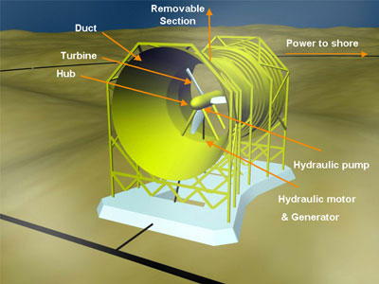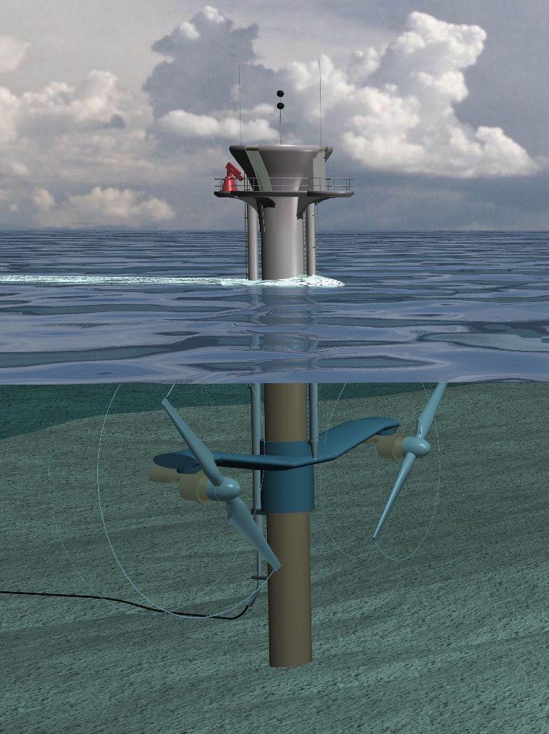
Figure 8 (above) and figure 9 (left): stream generator, can be completely submerged below water (figure 7) or partially above water (figure 8). All propellers are located underwater.

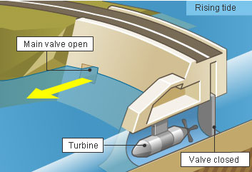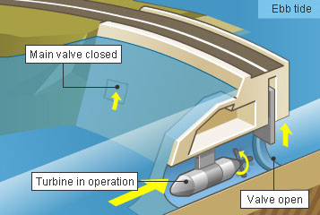
Figure 10 (left) and figure 11 (right): barrage tidal power plant, with the tide going out (Figure 10) and the tide going in (Figure 11).

Conclusion
Third generation technologies are capable of providing ample power and electricity generation, the potential output of these technologies is significant enough to constitute a sizable contribution to energy production and electricity generation. Many of these technologies, while not yet suitable for global implementation, are being successfully implemented and utilized today, though further research and development will likely increase their efficiency and output. The potential carbon emissions from these technologies are minimal, and in many cases, non-existent, however, beyond potential carbon emissions there are various environmental impacts that must be considered, some of which are not yet fully understood, prior to global implementation of these technologies.
Global energy and electricity demand continues to steadily rise, a trend that dictates that, while these third generation technologies all present feasible sources of renewable energy, they are unlikely to provide a total replacement for fossil fuel energy sources. It is however, important to note that these technologies, coupled with existing first and second generation technologies, could greatly lessen the portion of global power and electricity generation derived from fossil fuels.
Ultimately, the main limiting factor in the global implementation of these technologies is cost. The generation costs of these technologies may be low, but the installation, construction and maintenance costs are often extremely high. These significantly higher costs translate into energy that is not competitively priced, nor commercially profitable. These realities shape the conclusion of this article: the growing demands for cheap abundant energy coupled with the commercialization and profit oriented nature of energy and electricity generation severely diminish these technologies potential viability. Until such a time arrives when consumers around the world are prepared to shoulder the burden of significantly higher energy and electricity costs in exchange for cleaner, more sustainable and renewable sources, the viability of all renewable energy sources, particularly those that are not yet fully implemented, remains in question.

Works Cited

Annual Coal Report. (2011). U.S. Energy Information Administration (EIA). Retrieved May 21, 2012, from http://www.eia.gov/coal/annual/

Annual Energy Review. (2011) U.S. Energy Information Administration. Retrieved May 19, 2012, from http://www.eia.gov/totalenergy/data/annual/

Biomass Program: Biochemical Conversion Processes. (2008, February 22). U.S. DOE Energy Efficiency and Renewable Energy (EERE) Home Page. Retrieved May 24, 2012, from http://www1.eere.energy.gov/biomass/biochemical_processes.html

Electricity in the United States. (2012) U.S. Energy Information Administration. Retrieved from http://www.eia.gov/energyexplained/index.cfm?page=electricity_in_the_united_states
Elkhorn Biomass | Renewable Fuel. Sustainable Energy. (n.d.). Elkhorn Biomass | Renewable Fuel. Sustainable Energy. Retrieved May 24, 2012, from http://www.elkhornbiomass.com/energy.html
Geothermal Education Office - Power From the Earth's Heat. (n.d.). Geothermal Education Office. Retrieved May 23, 2012, from http://geothermal.marin.org/pwrheat.html

Global Warming Effects and Threats on Human Health. (2011) Natural Resources Defense Council. Retrieved May 21, 2012 from http://www.nrdc.org/helath/climate/

Greenhouse Gases. (2010). Natural Gas Air Emissions Facts. Retrieved May 21, 2012 from http://www.naturalgasairemissions.com/Greenhouse-Gases/Pages/Information.aspx

IEA - Home. (2011). IEA - Home. Retrieved May 29, 2012, from http://www.iea.org

International Energy Association. (2011) Key World Energy Statistics. Retrieved May 20, 2012, from http://www.iea.org/textbase/nppdf/free/2011/key_world_energy_stats.pdf

Mæhlum, Mathias. (n.d.). Geothermal Energy Pros and Cons. Energy Informative. Retrieved May 28, 2012, from
http://energyinformative.org/geothermal-energy-pros-and-cons/#.T8Q8-bCJea8
Mæhlum, Mathias. (n.d.). How a Geothermal Power Plant Generates. Energy Informative. Retrieved May 23, 2012, from http://energyinformative.org/how-a-geothermal-power-plant-generates-electricity/#.T8Q7jLCJea9
Mæhlum, Mathias. (n.d.). How Does Tidal Power Work? Energy Informative. Retrieved May 23, 2012, from http://energyinformative.org/how-does-tidal-power-work/#.T8RJK7CJea8
Mæhlum, Mathias. (n.d.). Tidal Energy Pros and Cons. Energy Informative. Retrieved May 23,
2012, from http://energyinformative.org/tidal-energy-pros-and-cons/#.T8RIo7CJea8
Mæhlum, Mathias. (n.d.). Hydroelectric Energy Pros and Cons. Energy Informative. Retrieved May 23, 2012, from http://energyinformative.org/hydroelectric-energy-pros-and-cons/#.T8T9kkV5F8E

National Mining Association. (2011) Fast Facts About Coal. Retrieved May 19, 2012, from http://www.nma.org/statistics/fast_facts.asp

NREL: Biomass Research - What Is a Biorefinery?. (2009, September 28).National Renewable Energy Laboratory (NREL) Home Page. Retrieved May 22, 2012, from http://www.nrel.gov/biomass/biorefinery.html
Rajvanshi, A. (1986). Alternative Energy In Agriculture. Maharashtra, India : CRC Press.

Renewable Energy Data Book. (2011) National Renewable Energy Laboratories (NREL). Retrieved May 23, 2012 from http://www.nrel.gov/analysis/pdfs/51680.pdf

Renewable Electricity Generation | energy forum. (2011). Discussion and debate about energy policy, energy security, and climate change | energy forum. Retrieved May 20, 2012, from http://energyforumonline.com/tag/renewable-electricity-generation

Renewables 2011 Global Status Report. (2011) REN21. Retrieved May 19, 2012 from http://www.ren21.net/Portals/97/documents/GSR/REN21_GSR2011.pdf

Stats and Links. (2010). Kilowatt Coal Co. Retrieved May 21, 2012, from
http://kilowattcoalco.com/StatsAndLink

Table 32 U.S. Coal Consumption by End-Use Sector, 2005-2011. (2011) US EIA. Retrieved May21, 2012 from http://www.eia.gov/coal/production/quarterly/pdf/t32p01p1.pdf
Tidal Energy. (n.d.). Ocean Energy Council | Green Wave Energy Sources. Retrieved May 23, 2012, from http://www.oceanenergycouncil.com/index.php/Tidal-Energy/Tidal-Energy.html
What Is Biomass. (n.d.). Biomass Energy Centre. Retrieved May 20, 2012, from www.biomassenergycentre.org.uk/portal/page?_pageid=76,15049&_dad=portal

Image Sources
1.2 MW Tidal Energy Turbine Ready for Installation. (2007, June 27). The Energy Blog. Retrieved May 23, 2012, from http://thefraserdomain.typepad.com/energy/2007/06/12-mw-tidal-ene.html
Energy Research. (2012) Lawrence Livermore National Laboratory. Retrieved May 23, 2012 from https://energy.llnl.gov/informatics.php
Lunar Energy Tidal Power. (2012, June 7). Renewable Energy UK. Retrieved May 23, 2012, from http://www.reuk.co.uk/Lunar-Energy-Tidal-Power.htm
Lund, J. (2007). CHARACTERISTICS, DEVELOPMENT AND UTILIZATION OF GEOTHERMAL RESOURCES. Retrieved May 23, 2012, from geoheat.oit.edu/bulletin/bull28-2/art1.pdf

Renewables 2011 Global Status Report. (2011) REN21. Retrieved May 19, 2012 from http://www.ren21.net/Portals/97/documents/GSR/GSR2011_Figures.pdf
Tidal Barrages. (n.d.). World Colleges Information. Retrieved May 23, 2012, from http://www.worldcolleges.info/Science-Tech/tidal-barrages.php

