Tables worksheet

- Tables (rows and columns) (see p. 131)
EXERCISE A: add two more rows (400 and 500)
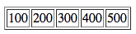
EXERCISE B: add one more column
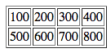
EXERCISE C: remove all borders

- Table Headers (see p. 132)
EXERCISE A: add another row with header + regular content
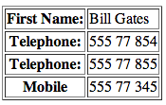

- Spanning Columns (“colspan”) (see pp. 133-134)
EXERCISE A: Create a new column under “Telephone”
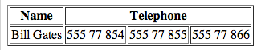
EXERCISE B: Create a new row under “Bill Gates.”
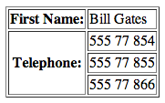

EXERCISE C: Add a caption to both Tables. (see W3 Schools link)
<table>
<caption>XXXXXX</caption>
<tr>

- Tags inside a Table
EXERCISE A: See if you can reproduce this table
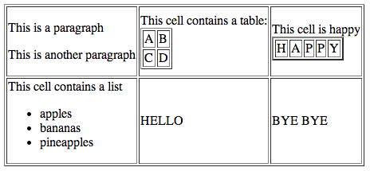

- Long Tables
<table border="1">
<thead>
<tr>
<th align="left">Name</th>
<th align="left">No. of Comm Majors</th>
<th align="left">No. of Seniors</th>
</tr>
</thead>
<tbody>
<tr>
<th>Jennifer Pauk</th>
<td>Comm</td>
<td>Senior</td>
</tr>
</tbody>
<tfoot>
<tr>
<td></td>
<td>10</td>
<td>6</td>
</tfoot>
</table>

