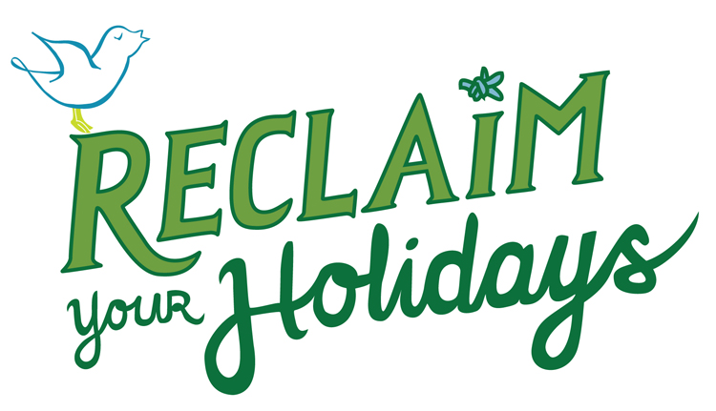
PRACTICAL WAYS TO CREATE MEANING
Assessing Your Daily Finances: A Self-Reflection Exercise

In this exercise, you’ll look at your daily finances and what you spend.

1) For a week, write down how you spend your money each day.
2) Think about the amount of money you spent on various things (activities, food, clothing, entertainment, etc.), if it was a need or a want, and how much pleasure you derived from each.
3) Then rate those items on the meaning/pleasure you derived from them. Use a scale of 1 to 5, with 5 being “a great deal of meaning or pleasure” and 1 being “no meaning or pleasure.”
4) To the right of the Meaning/Pleasure columns, indicate if you would like to spend more or less money on that item. If you want to spend more money, put one or two pluses (+ +). Use the minus sign if you want to spend less money, and a double minus if you want to spend a lot less money (- -). If you are satisfied with the amount of money you spent on an item, write in a zero (0).
5) Feel free to make notes—such as what might work better, or why you don’t find meaning or pleasure in a particular item —in the Comments column.
6) Add spaces to list more spending items as needed.
7) A few examples are shown at the top of the chart.

Activity | Need/  Want? | Meaning  (rank 1-5) | Pleasure  (rank 1-5) | More, less, or about the same amount of money (+, -, 0) | Comments
EXAMPLE: DAY I
Coffee w/ friends $4.00 | N | 5 | 5 | 0 | Chance to catch up
New winter boots $90.00 | W | 3 | 4 | - | Would my last year’s boots be o.k.?
Online DVD purchase $10.00 | W | 3 | 4 | - | Not a real need; maybe look first and return to buy?
Friday night out $20 | W | 3 | 5 | - | It was o.k. but cost a lot
Groceries $50 | N | 5 | 5 | 0 | Food & household supplies

What did you learn from your week of tracking your finances? What would you like to do differently?

References: Ben-Shahar, Tal, Ph.D, Happier: Learn the Secrets to Daily Joy and Lasting Fulfillment, New York: McGraw Hill, 2007.
Robinson, Jo and Jean Coppock Staeheli, Unplug the Christmas Machine, New York: William Morrow, 1991.
This exercise was written by Susan Salterberg, University of Northern Iowa Center for Energy & Environmental Education. This project is made possible thanks to funding support from the REAP Conservation Education Program and the Iowa Department of Natural Resources Solid Waste Alternatives Program. Find more at ReclaimYourHolidays.org.

