Name ________________
Living Well to Protect the Environment
I need these things to survive.  1._________________________________________  2.________________________________________  3.________________________________________ | I want these things.  1.__________________________________________  2.__________________________________________  3.__________________________________________

4. How do the things that make me and my family happy connect to the earth?
____________________________________ connection________________________________________
____________________________________ connection________________________________________
5. List 3 natural resources and a product that is made from it.
Natural Resource | Product
1.
2.
3.

6. Circle the first stage in a t-shirt’s life cycle.

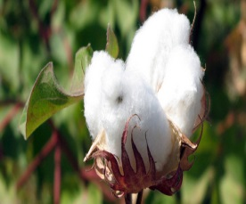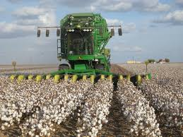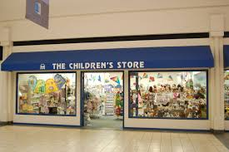
Cotton Plant Harvesting Cotton Clothing Store

7. Circle the second stage in a t-shirt’s life cycle.

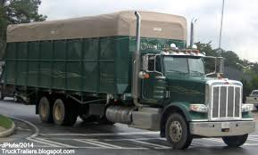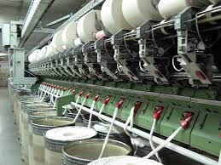
Transportation Harvesting Cotton Clothing Factory

8. Circle the third stage in a t-shirt’s life cycle.
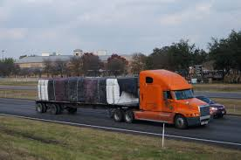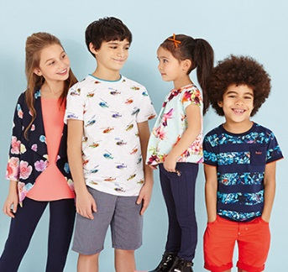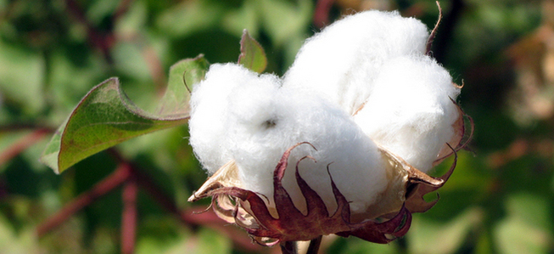
Transportation Wear Clothing Cotton Plant

9. Circle the answer that is best for the environment.

Recycle Reuse Reduce

10. What did you like most about the Community Engagement Project?
_________________________________________________________________________________________
Developed by Karen Bouska, Wapsie Valley first-grade teacher

